DATA SCIENCE TOOLBOX: PYTHON PROGRAMMING
PROJECT REPORT
(Project Semester January-April 2025)

“Case Study Of Customer Loyalty History- Analysis Dashboard”

Submitted by

Abhik Konar

Registration No.12306328

Programme and Section: -B. Tech in CSE (K23FD)
Course Code INT375

Under the Guidance of
Baljinder Kaur (UID:27952)

Discipline of CSE/IT

School of Computer Science & Engineering
Lovely Professional University, Phagwara

CERTIFICATE

- This is to certify that Abhik Konar bearing Registration no. 12306328 has completed INT375 project titled, “Case Study Of Customer Loyalty History-Analysis Dashboard” under my guidance and supervision. To the best of my knowledge, the present work is the result of his/her original development, effort and study.

Baljinder Kaur
Assistant Professor
School of Computer Science & Engineering
Lovely Professional University
Phagwara, Punjab.

Date: 12.04.2025

DECLARATION

I, Abhik Konar, student of B. Tech in Computer Science & Engineering under CSE/IT Discipline at, Lovely Professional University, Punjab, hereby declare that all the information furnished in this project report is based on my own intensive work and is genuine.

Date: 12.04.2025 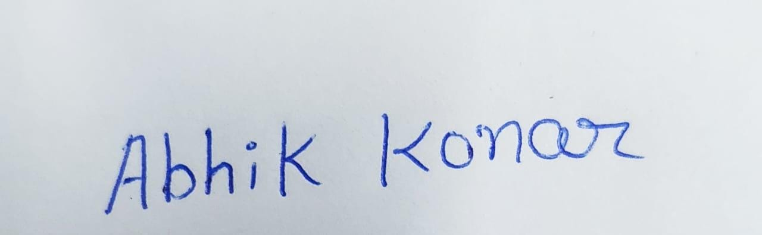
Registration No. 12306328 Abhik Konar

ACKNOWLEDGEMENT

I would like to take a moment to sincerely thank everyone who helped me throughout this project. Without their support, this wouldn’t have been possible.
First, I’m truly grateful to my faculty, Baljinder Kaur, for their continuous guidance and encouragement. Her support kept me focused and motivated from the very beginning.
I’d also like to thank my friends and classmates who shared their thoughts and gave me helpful feedback along the way — it really made a difference.
Working on this project was a great experience for me, and I’ve learned so much.

Table of Content

1. Introduction
2. Source of dataset
3. Dataset Preprocessing
4. Analysis on dataset (for each objective)
- General Description
- Specific Requirements
- Analysis results
- Visualization
5. Conclusion
6. Future scope
7. References

1.INTRODUCTION: -
In this project, I worked with a customer loyalty dataset to explore different patterns and trends in customer behaviours. The data includes information like salary, gender, education level, city, and when customers enrolled or cancelled their services. My main goal was to understand how these factors relate to customer loyalty and how we can find useful insights from them.
To do this, I used Python and some popular libraries like Pandas, Matplotlib and Seaborn. I cleaned the dataset by filling in missing values and then created different types of visualizations to make the data easier to understand. For example, I looked at how salary is distributed, how male and female customers are spread across cities, and how customer cancellations changed over the years.
Working on this project helped me improve my data analysis skills and understand the importance of customer data in real-life business decisions. It also showed me how powerful visualizations can be when it comes to telling stories from raw data.

2.Source Of Dataset: -
Link: -https://app.mavenanalytics.io/datasets?order=-fields.dateUpdated&search=airline+loyalty+program

Screenshot: -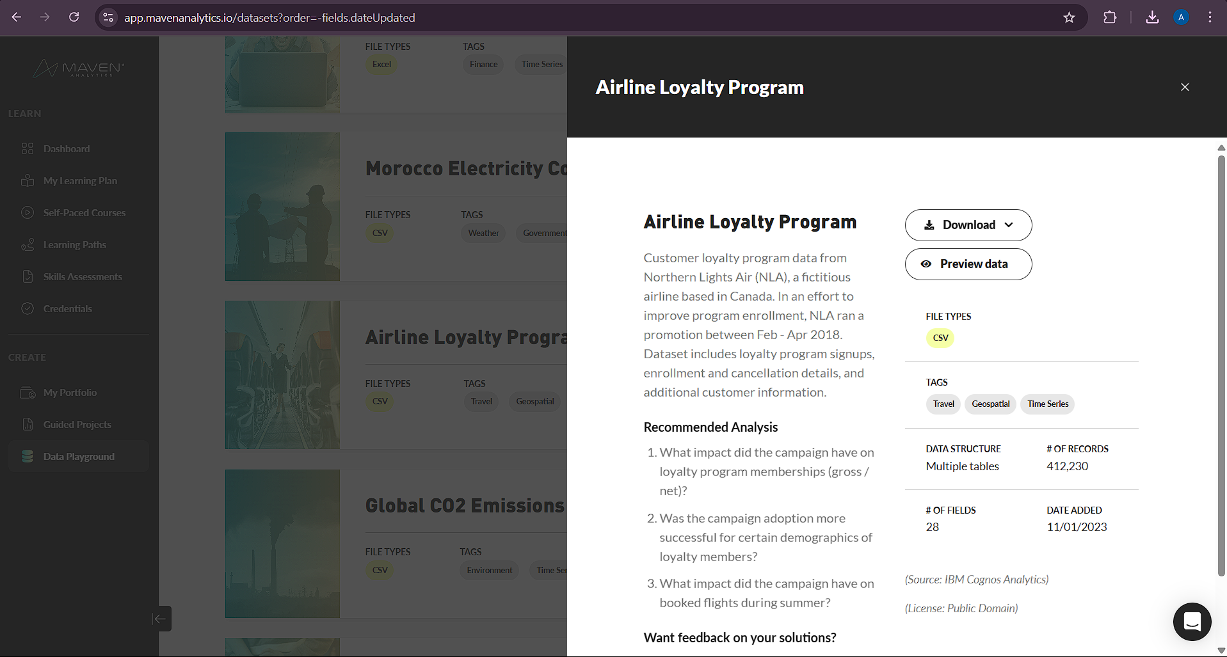

3.Dataset Preprocessing: -
Before diving into the analysis, I checked the dataset that it was clean or not. When I first opened it, I noticed some missing values in columns like Salary, Cancellation Year, and Cancellation Month. So, I filled in those missing spots using the mean for Salary and the median for the Cancellation fields. This helped keep the data consistent without making big changes to its overall structure.
Next, I created a couple of new columns that weren’t originally in the dataset. For example, I converted Enrollment Month and Cancellation Month numbers into their full month names (like “January” instead of 1). This made the visuals more readable and easier to understand.
I also did some basic formatting and checked for column types, just to make sure everything was in the right format — especially for things like dates and categories. Once all of this was done, the data was ready for analysis and visualization.

4.Analysis on dataset: -

i. General Description
- Dataset: Customer Loyalty History
- Contents: Contains customer information including demographics (Gender, City, Education), financials (Salary, CLV), and enrollment/cancellation details.
- Size: Not explicitly mentioned but contains multiple rows/columns (inferred from visualizations).
- Data Types: Mixed (numeric: Salary, CLV; categorical: Gender, City; datetime-related: Enrollment/Cancellation Year/Month).
- Missing Values: Handled for Salary, Cancellation Year, and Cancellation Month (filled with mean/median).
ii. Specific Requirements
- Data Cleaning:
  - Handle missing values in Salary (filled with mean), Cancellation Year and Cancellation Month (filled with median).
  - Convert numeric months to month names (e.g., 1 → January).
- Analysis Goals:
  - Explore distributions (Gender, Salary, CLV).
  - Compare enrollment/cancellation trends by gender and time.
  - Visualize relationships (Education vs. Gender, City demographics, etc.).
iii. Analysis Results
- Demographics:
  - Gender Distribution: Slightly skewed (e.g., 55% Female, 45% Male from pie chart).
  - Education vs. Gender: Certain education levels may dominate by gender (e.g., Females higher in bachelor’s degrees).
- Financials:
  - Salary: Right-skewed distribution (most customers earn moderate salaries).
  - CLV (Customer Lifetime Value): Concentrated in a specific range (peaks in mid-values).
- Temporal Trends:
  - Enrollment: Peaks in certain years/months (heatmap shows higher enrollments in mid-years/specific months).
  - Cancellations: Possible seasonal patterns (e.g., higher cancellations in later years for one gender).
- Geospatial:
  - Top cities show gender imbalances (e.g., City A has more Female customers).
iv. Visualization
- Categorical Data:
  - Education vs. Gender: Bar plot shows gender split per education level
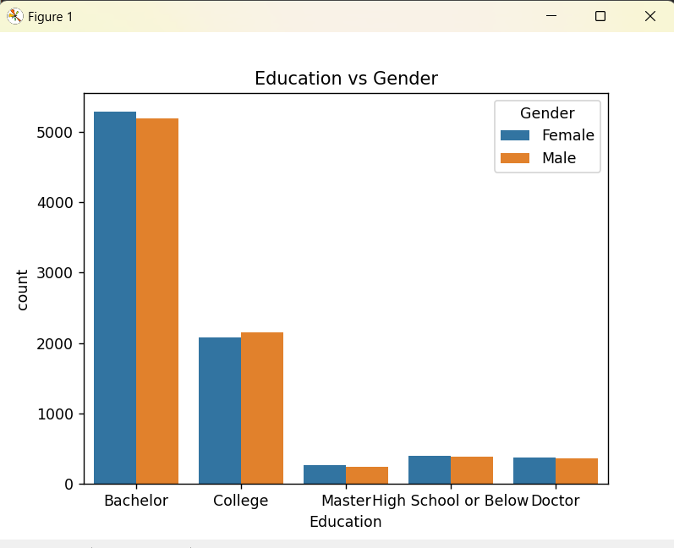

  - City Distribution: Top 10 cities with gender breakdown (bar plot)

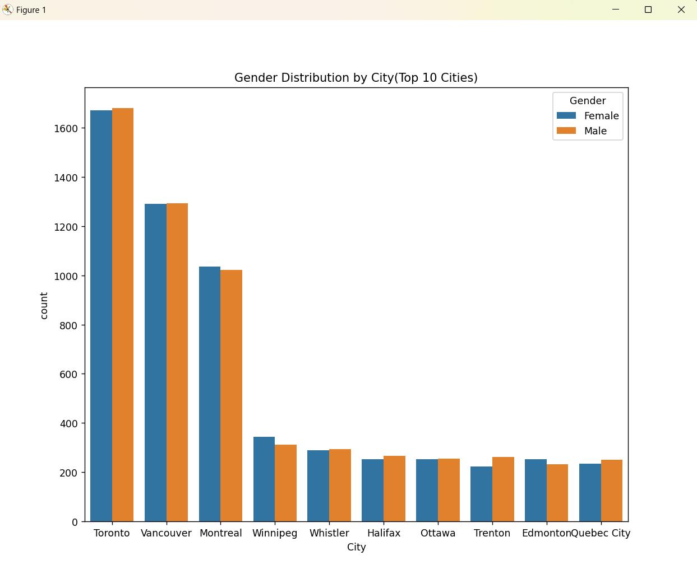

- Distributions:
  - Salary: Histogram with KDE highlights skewness
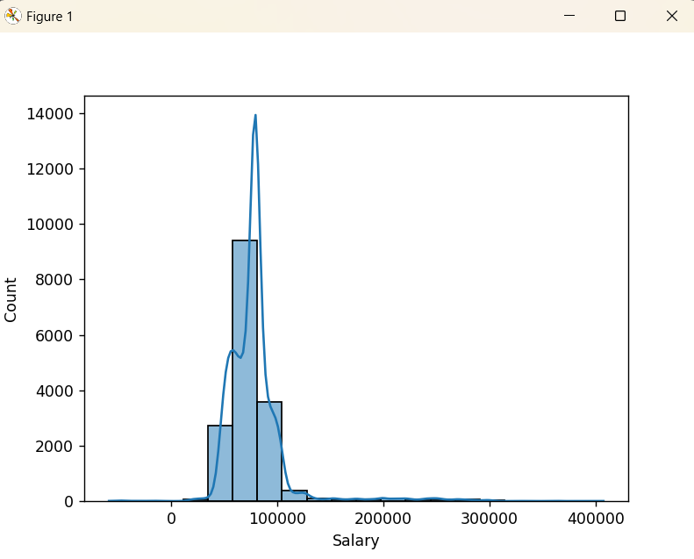

  - CLV: KDE plot shows concentration around a mean.

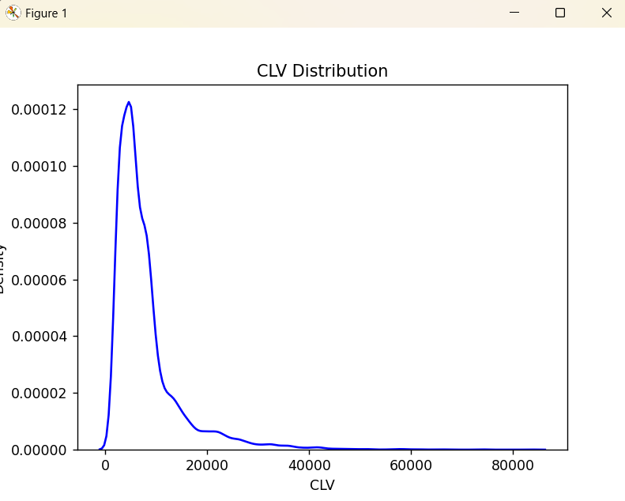

- Temporal Trends:
  - Enrollment/Cancellation by Year: Line plots with markers show trends split by gender.
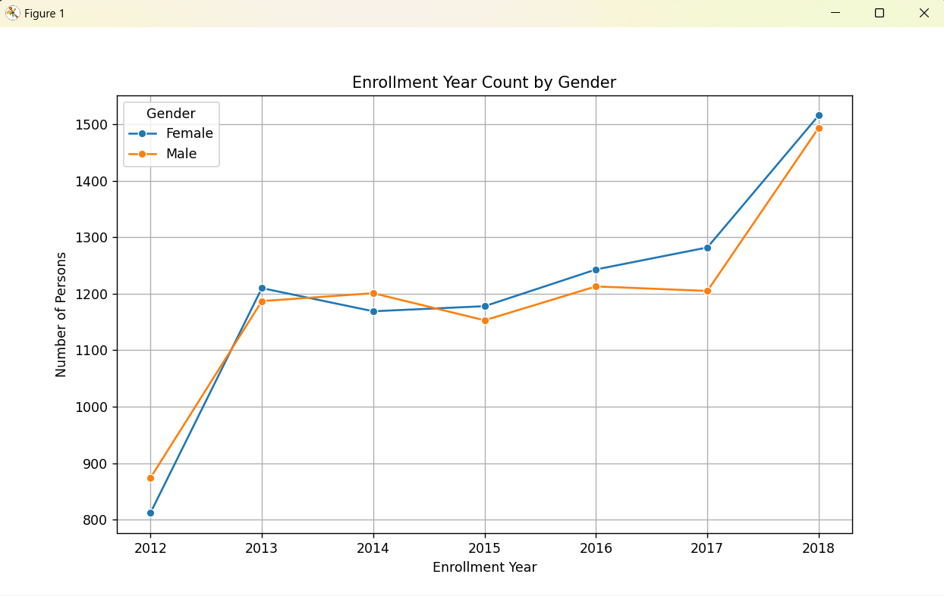
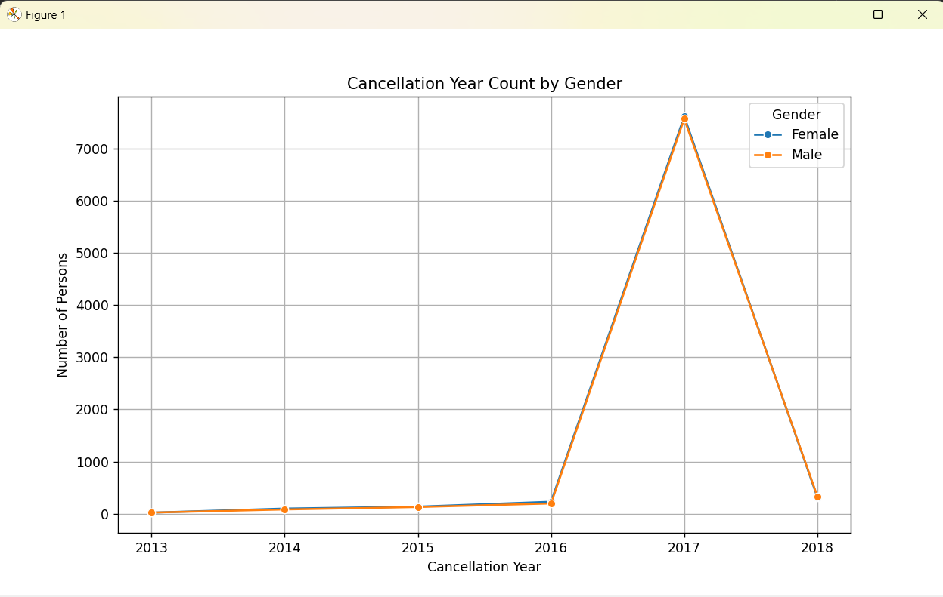

  - Enrollment Heatmap: Year vs. Month heatmap reveals seasonal patterns.

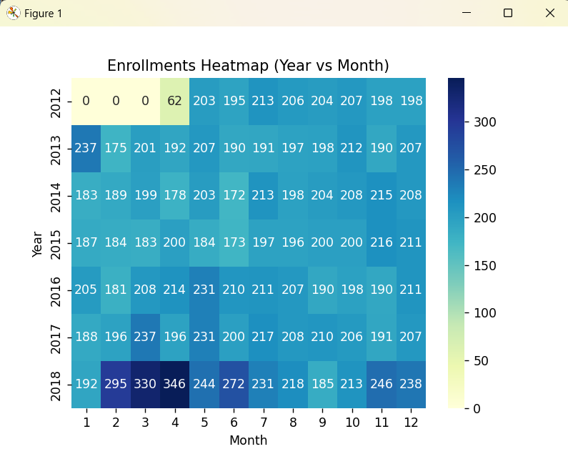

- Gender Insights:
  - Pie chart summarizes gender ratio.

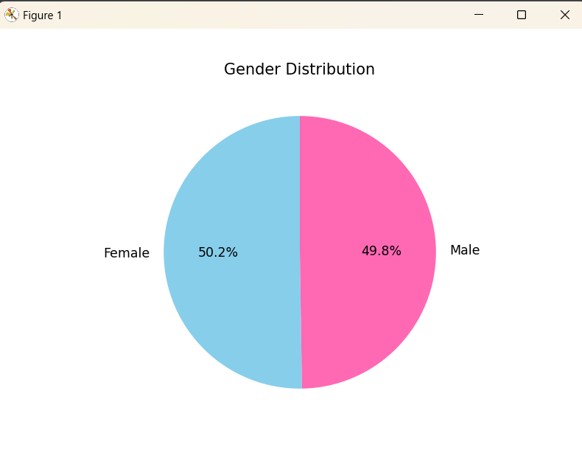

5.Conclusion: -
In this project, we analysed a Customer Loyalty History dataset to understand customer behaviour, demographics, and trends in enrollments and cancellations. Here’s what we found:
- Customer Demographics
  - The dataset had a slightly higher percentage of female customers than male.
  - Certain education levels were more common among specific genders (e.g., more women with bachelor’s degrees).
  - Some cities showed noticeable gender imbalances, which could be useful for targeted marketing.
- Financial Insights
  - Most customers had moderate salaries, with a few high earners (right-skewed distribution).
  - Customer Lifetime Value (CLV) was concentrated in a mid-range, suggesting a stable but not highly premium customer base.
- Enrollment & Cancellation Trends
  - Enrollment rates varied by year and month, with some periods (like mid-year) seeing higher sign-ups.
  - Cancellations showed possible seasonal trends, with certain years experiencing more drop-offs, especially among one gender.
- Key Takeaways
  - Marketing Strategy: Focus on high-enrollment months to boost sign-ups and investigate why cancellations peak in certain periods.
  - Customer Retention: Since CLV is mid-range, strategies to increase customer value (e.g., loyalty programs) could improve revenue.
  - Gender & Location-Based Targeting: Adjust campaigns based on city and gender trends for better engagement.

6.Future Scope: -
1. Predictive Analytics (ML Models)
We can apply machine learning algorithms to predict:
- Churn likelihood (who is likely to cancel)
- High CLV potential customers (who will be most profitable in the long run)
Some possible models:
- Logistic Regression / Random Forest (for churn prediction)
- Linear Regression (to estimate CLV)

2. Customer Segmentation (Clustering)
Using K-Means or Hierarchical Clustering, customers can be grouped into:
- High-value loyal customers
- Low-engagement customers
- At-risk customers
This helps in personalized marketing and targeted campaigns.

3. Dynamic & Interactive Dashboards
Instead of static charts, we can:
- Use Power BI or Tableau to build interactive dashboards
- Add filters, drilldowns, and time sliders for more business-friendly analysis

4. Loyalty Program Optimization
With insights from CLV, churn, and customer behavior:
- Recommend better reward strategies
- Identify which loyalty card types drive more value
- Suggest improvements to customer retention tactics

5. Time Series Forecasting
Use techniques like:
- ARIMA
- Prophet To forecast enrollments and cancellations, which helps in resource planning and decision making.

6. Integrate External Data
In the future, the dataset can be enhanced by:
- Merging customer behavior data (e.g., purchase frequency, product categories)
- Adding geographic income data for deeper demographic analysis

7. Web-based Application
Turn this analysis into a dashboard web app using tools like:
- Flask + Plotly Dash
- Streamlit
This can allow managers to interact with the insights anytime, without needing to run the script.

8. Automated Reporting
Schedule weekly/monthly reports with updated KPIs:
- Total new enrollments
- Churn rate by month
- Revenue impact due to churn
Using Python automation or tools like Power Automate / Airflow.

9. Anomaly Detection
Set up alerts if:
- Sudden spike in cancellations
- Drop in average salary of new enrollments
- Loyalty card underperformance

10. Recommendation System (Advanced)
Eventually, the business can use this data to recommend:
- Personalized loyalty benefits
- Special offers based on customer profile or city

7.References: -
[1] T. Verbeke, K. Dejaeger, D. Martens, J. Hur, and B. Baesens, “New insights into churn prediction in the telecommunication sector: A profit driven data mining approach,” European Journal of Operational Research, vol. 218, no. 1, pp. 211–229, Apr. 2012.
[2] P. Kotler and K. L. Keller, Marketing Management, 15th ed., Pearson Education, 2015.
[3] W. R. Reinartz and V. Kumar, “The impact of customer relationship characteristics on profitable lifetime duration,” Journal of Marketing, vol. 67, no. 1, pp. 77–99, Jan. 2003.
[4] J. Brownlee, “Time Series Forecasting with the Prophet Library in Python,” Machine Learning Mastery, [online]. Available: https://machinelearningmastery.com/time-series-forecasting-with-prophet/
[5] R. Dash, P. Sahoo, and S. Mohapatra, “Customer churn prediction using machine learning: A case study on telecom sector,” in Proc. IEEE Intl. Conf. on Computation System and Information Technology for Sustainable Solutions, 2016, pp. 42–46.
[6] Microsoft Corporation, “Power BI Documentation,” [Online]. Available: https://learn.microsoft.com/en-us/power-bi/
[7] M. Lantz, Machine Learning with R, 2nd ed., Packt Publishing, 2015.

LINKEDIN: -
URL: https://www.linkedin.com/in/abhik-konar-22838128b/recent-activity/all/

